**Genii Analytics | Interactive Reports | User Guide**

29 Jan-21

Contents

General Icons 2

Dashboard 3

Performance Metric Results 5

Contact Disposition Matrix 7

Root Cause Analysis 9

Lift Opportunities 11

Agent Metric Results 13

Performance Tracker 15

Trending 18

Performance Metric Drilldown 20

Gauge Performance Metric Results 22

Calibration Assessor Summary 23

# General Icons

Open Filter Icon



This icon will display your filter options per report. And will therefore have different selections options depending on your campaign configurations and the report selected.

Clear Filter icon



This icon will clear all existing filter selections and set all the default parameters.

The dates will default to the campaign set dates.

Info icon



This will show on some reports and it will display information like the default settings for the report you are on.

This icon may also contain a user guide.

# Dashboard

This is an overall view of the section scores.

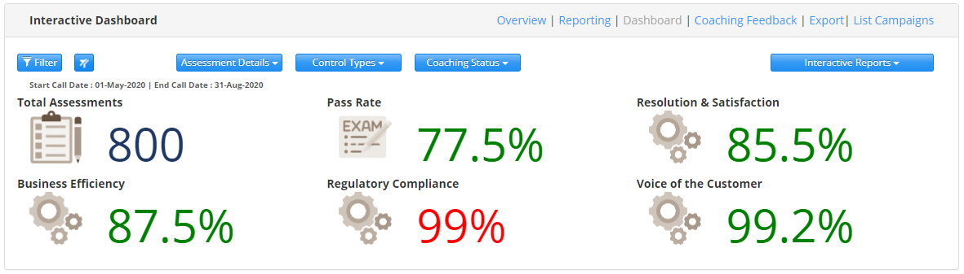

The filter will default as follows:

1. All section data will default to both downstream (agent) controllable and upstream (business) non controllable failures.
2. All section data (excluding BI allocated sections) will display (not only the top 4).

It will display in the order that it appears on your campaign form.

1. Pass Rate will now include both downstream and upstream failures.
2. Total Assessments will include all successful assessments (passed and failed), including assessments were N/A was selected for all sections.
3. Calls where all the sections were allocated with an N/A will only be included in the Total Assessments and will not be included in the denominator of the Pass Rate or Section Scores.

You will be able to filter as follows (depending on your campaign setting)

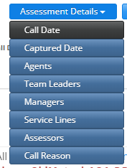

**Assessment details:**

1. Call Date
2. Captured Date
3. Agent
4. Team Leader
5. Manager
6. Service Lines
7. Assessors
8. Call Reason

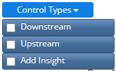**Control Types:**

1. Downstream (Agent controllable)
2. Upstream (Business controllable)
3. Add Insights (Business Intelligence)

**Coaching Status:**

(this will depend on your site)

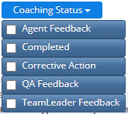The example shows

1. Agent Feedback
2. Completed
3. Corrective Action
4. QA Feedback
5. Team Leader Feedback

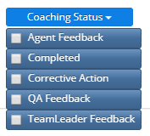***Please note:***

1. The filter will populate according to captured data except for the call date which will default to your campaign start and end date.

ie: this means if you have no successful captures for a specific agent, that agent will not be part of the filter.

1. Only the date filter will affect the other filters.

ie: This means if you select a date range that excludes a specific agent, that agent will not be on your filter list. However, if you select a specific Team Leader, all agents will still display.

1. Scores are based on the Control type selected on level 3 (furthest child will no longer be a factor). If question level 3 does not a control type or has a BI control type, it will not be included in the calculation.
2. Sentiment for Section Scores

Negative = Failures/Assessment  
Positive = 1 - (Failures/Assessments)

1. The Dashboard will not work without section targets*

# Performance Metric Results

This is an overall view of the output metric scores.

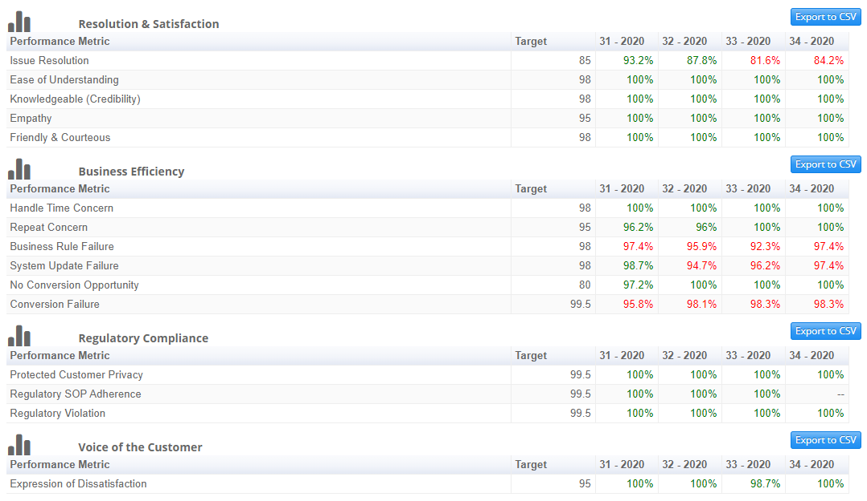

The filter will default as follows:

1. All section data will default to all control types, downstream (agent) controllable, upstream (business) non controllable failures and business Insights.
2. Section data will display in the order that it appears on your campaign form.
3. Output Metric data will display in the order that it appears on your campaign form.
4. All Sections will be displayed not just the top 4. Resolution & Solution, Business Efficiency, Regulatory Compliance and Voice of the Customer.
5. You will now be able to compare weeks or months.
6. As before your end data selections determines the data set shown.
7. Export Function added.
8. Weeks start on a Monday and week 53 will become part of week 1 of the new year.
9. Note the last date determines your data set. Therefore, ensure that you select the correct date. ie: for weeks ensure your end date is on a Sunday and for months that you’ve selected the last day of that month.

You will now be able to filter as follows (depending on your campaign setting)

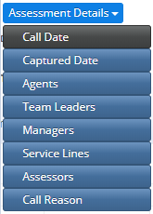**Assessment details:**

(this will depend on your campaign)

1. Call Date
2. Captured Date
3. Agent
4. Team Leader
5. Manager
6. Service Lines
7. Assessors
8. Call Reason

**Control Types:**

1. Downstream (Agent controllable)
2. Upstream (Business controllable)
3. Add Insights (Business Intelligence)

**Coaching Status:**

(this will depend on your site)

The example shows

1. Agent Feedback
2. Completed
3. Corrective Action
4. QA Feedback
5. Team Leader Feedback

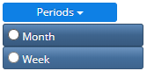 **Period:**

1. Month
2. Week

# Contact Disposition Matrix

Displays Call Reason distribution percentages, along with the associated Call Drive Matrix items.

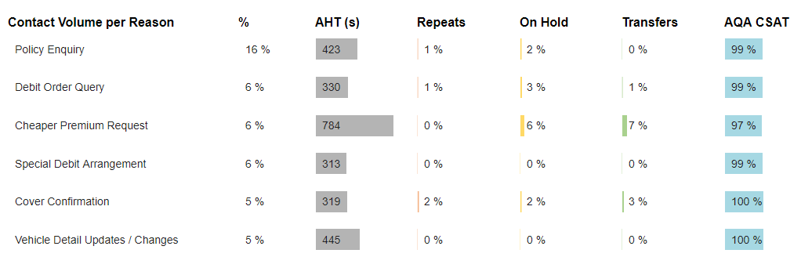

The filter will default as follows:

1. Call Drive Matrix (Campaign dependant)
   1. FCR (first call resolution)
   2. SCR (Sales/Collections/Retention)
   3. AHT (Average Handling Time)
   4. Average Hold Time
   5. Average Transfers
   6. AQA CSAT
   7. Pass Rate
2. If the entries for Hold, Transfers, FCR and SCR are not Yes/No question the results here are not valid.
3. Calculations are directly associated with the call reasons and number thereof and not with unique assessment ids.

You will be able to filter as follows (depending on your campaign setting)

**Assessment details:**

1. Call Date
2. Captured Date
3. Agent
4. Team Leader
5. Manager
6. Service Lines
7. Assessors
8. Call Reason

**CDM Metrics:**

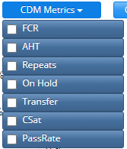The example shows

1. FCR
2. AHT
3. Repeats
4. On Hold
5. Transfer
6. CSAT / DSAT
7. Pass Rate

**Coaching Status:**

1. Agent Feedback
2. Completed
3. Corrective Action
4. QA Feedback
5. Team Leader Feedback

# Root Cause Analysis

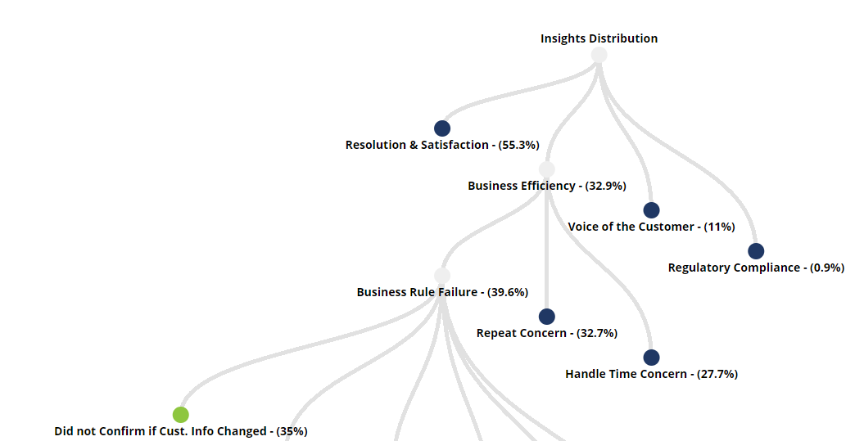

The filter will default as follows:

1. All section data will default to all control types, downstream (agent) controllable, upstream (business) non controllable failures and business Insights.
2. You can now exclude sections from your root cause analysis, or only view one branch at a time.
3. Lowest child comments will be limited to the top 1000 comments.

You will be able to filter as follows (depending on your campaign setting)

**Assessment details:**

(this will depend on your campaign)

1. Call Date
2. Captured Date
3. Agent
4. Team Leader
5. Manager
6. Service Lines
7. Assessors
8. Call Reason

**Control Types:**

1. Downstream (Agent controllable)
2. Upstream (Business controllable)
3. Add Insights (Business Intelligence)

**Coaching Status:**

(this will depend on your site)

The example shows

1. Agent Feedback
2. Completed
3. Corrective Action
4. QA Feedback
5. Team Leader Feedback

**Sections:**

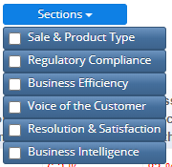(this will depend on your campaign)

The example shows

1. Sales & Product Type
2. Regulatory Compliance
3. Business Efficiency
4. Voice of the Customer
5. Resolution & Satisfaction
6. Business Intelligence

# Lift Opportunities

Gives the potential opportunity to improve results and the associated cost reduction or effect by addressing a reoccurring issue (causal factor / root cause).

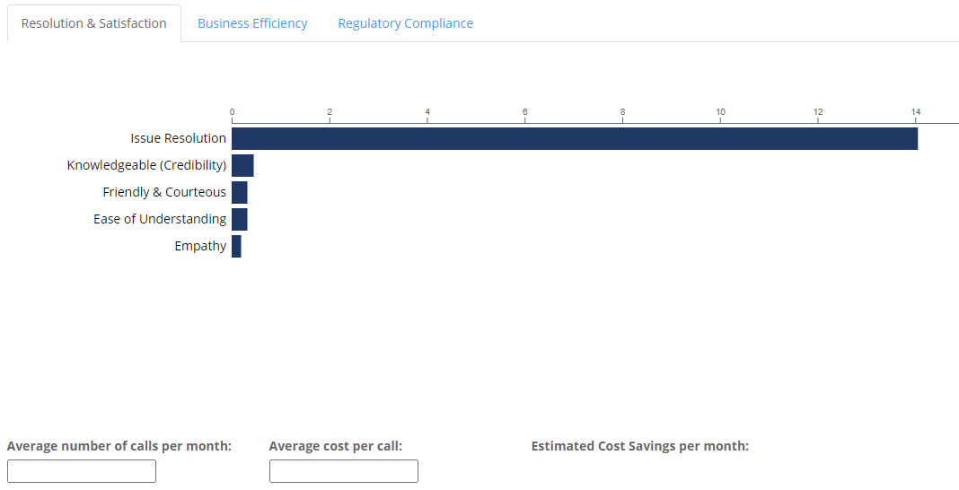

The filter will default as follows:

1. All Sections will show, in the order they appear on the campaign.
2. When you hover over the bars you will see the lift percentage.
3. The calculation can now be done on the lowest level.
4. Lift will be restricted to the top 10 where applicable.

You will be able to filter as follows (depending on your campaign setting)

**Assessment details:**

1. Call Date
2. Captured Date
3. Agent
4. Team Leader
5. Manager
6. Service Lines
7. Assessors
8. Call Reason

**Control Types:**

1. Downstream (Agent controllable)
2. Upstream (Business controllable)
3. Add Insights (Business Intelligence)

**Coaching Status:**

1. Agent Feedback
2. Completed
3. Corrective Action
4. QA Feedback
5. Team Leader Feedback

# Agent Metric Results

This is an overall view of the output metric scores per agent per month.

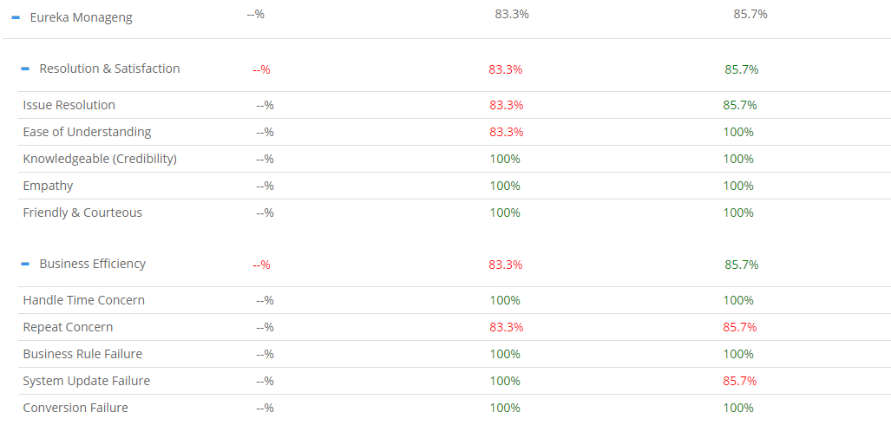

The filter will default as follows:

1. All section data will default to downstream (agent) controllable.
2. Section data will display in the order that it appears on your campaign form.
3. Output Metric data will display in the order that it appears on your campaign form.
4. As before your end data selections determines the data set shown.
5. The export Function will export the lowest level (output metric scores)

You will be able to filter as follows (depending on your campaign setting)

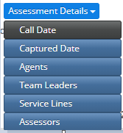**Assessment details:**

1. Call Date
2. Captured Date
3. Agent
4. Team Leader
5. Service Lines
6. Assessors

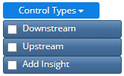**Control Types:**

1. Downstream (Agent controllable)
2. Upstream (Business controllable)
3. Add Insights (Business Intelligence)

# Performance Tracker

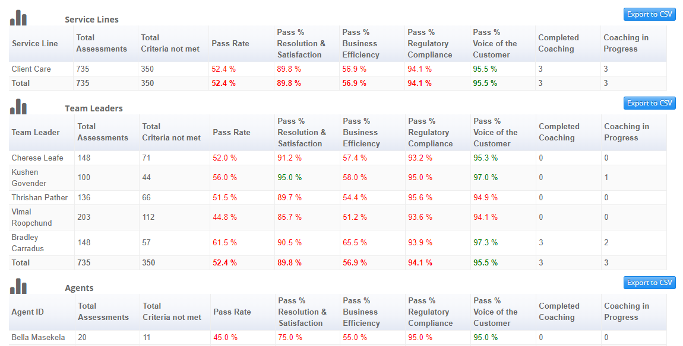

The filter will default as follows:

1. All section data and Pass Rate will default to downstream (agent) controllable.
2. Add Insights (BI) and or upstream (business) non controllable failures can be added using the Control Type filter.
3. Section data will display in the order that it appears on your campaign form, up to 4 sections.
4. The pass rate includes all applicable sections. However, if you want to see the hidden section scores you can select them using the sections filter, your pass rate will change according to the sections you have selected.
5. If you select more than 4 sections only the sections displayed will affect pass rate.
6. Total Assessments will include all successful assessments (passed and failed), including assessments where N/A was selected for all sections.
7. The tables will include Manager where applicable.

You will be able to filter as follows (depending on your campaign setting)

**Assessment details:**

1. Call Date
2. Captured Date
3. Agent
4. Team Leader
5. Manager
6. Service Lines
7. Assessors
8. Call Reason

**Control Types:**

1. Downstream (Agent controllable)
2. Upstream (Business controllable)
3. Add Insights (Business Intelligence)

**Coaching Status:**

(this will depend on your site)

The example shows

1. Agent Feedback
2. Completed
3. Corrective Action
4. QA Feedback
5. Team Leader Feedback

**Sections:**

(this will depend on your campaign)

The example shows

1. Sales & Product Type
2. Regulatory Compliance
3. Business Efficiency
4. Voice of the Customer
5. Resolution & Satisfaction
6. Business Intelligence

***Please note:***

1. The filter will populate according to captured data except for the call date which will default to your campaign start and end date.

ie: this means if you have no successful captures for a specific agent, that agent will not be part of the filter.

1. Only the date filter will affect the other filters.

ie: This means if you select a date range that excludes a specific agent, that agent will not be on your filter list. However, if you select a specific Team Leader, all agents will still display.

1. The data in the pop-up will always display the full estate – this may change in the future.

# Trending

Trending is the graphical representation of the Performance Metric Results.

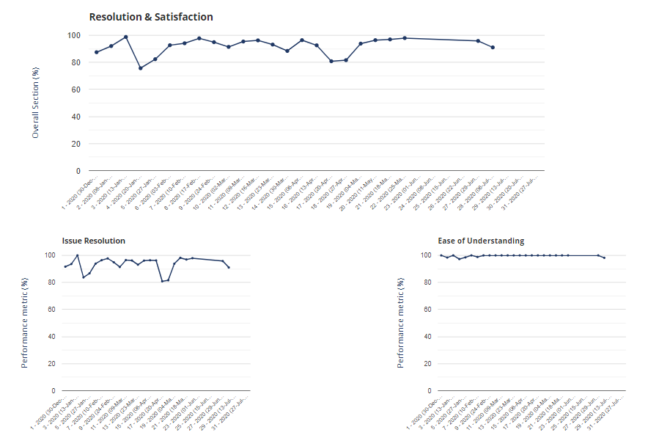

The filter will default as follows:

1. The Default Control Type will include upstream (business) and downstream (agent) attributes.
2. All Sections will show, in the order they appear on the campaign.
3. A Target Line has been added.
4. Month or Week trends can be viewed.

You will be able to filter as follows (depending on your campaign setting)

**Assessment details:**

1. Call Date
2. Captured Date
3. Agent
4. Team Leader
5. Manager
6. Service Lines
7. Assessors
8. Call Reason

**Control Types:**

1. Downstream (Agent controllable)
2. Upstream (Business controllable)
3. Add Insights (Business Intelligence)

 **Period:**

1. Month
2. Week

**Coaching Status:**

1. Agent Feedback
2. Completed
3. Corrective Action
4. QA Feedback
5. Team Leader Feedback

# Performance Metric Drilldown

This a high-level view of your failures / insights

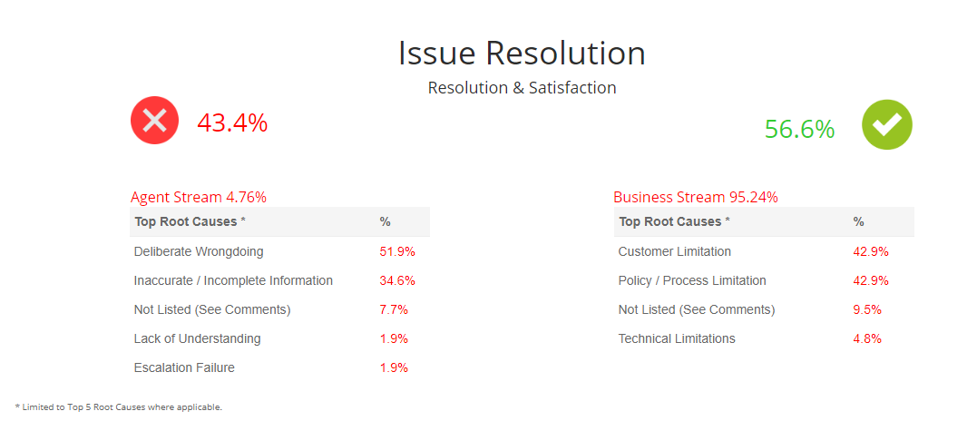

The filter will default as follows:

1. All section data will default to all control types, downstream (agent) controllable, upstream (business) non controllable failures and business Insights.
2. Failures / Insights indicated by the cross icon.

You will now be able to filter as follows (depending on your campaign setting)

**Assessment details:**

(this will depend on your campaign)

1. Call Date
2. Captured Date
3. Agent
4. Team Leader
5. Manager
6. Service Lines
7. Assessors
8. Call Reason

**Coaching Status:**

(this will depend on your site)

The example shows

1. Agent Feedback
2. Completed
3. Corrective Action
4. QA Feedback
5. Team Leader Feedback

**Performance Metrics**

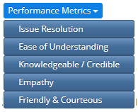(this will depend on your campaign)

The example shows

1. Issue Resolution
2. Ease of Understanding
3. Knowledgeable / Credible
4. Empathy
5. Friendly & Courteous

The following reports are specific to the Quality Manager Role (those who manager assessors/auditors) and will not be part of the standard reports.

# Gauge Performance Metric Results

This report gives you the Output Metric Accuracies per Gauge.

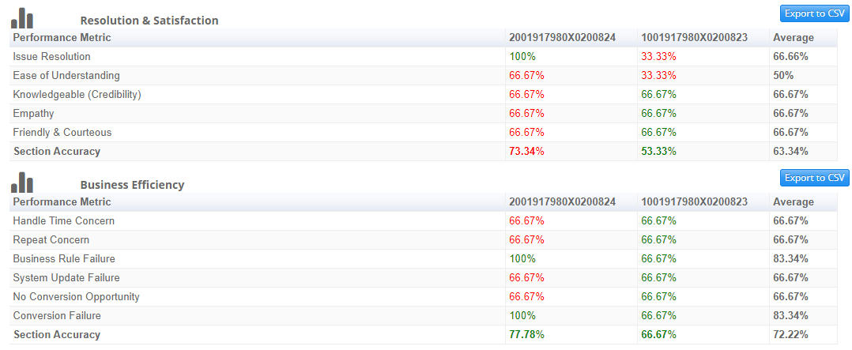

You will now be able to filter as follows with reference to the Gauge capture.

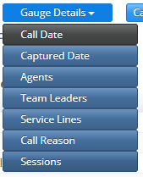**Gauge details:**

(this will depend on your campaign)

1. Call Date
2. Captured Date
3. Agent
4. Team Leader
5. Service Lines
6. Call Reason
7. Sessions (Connection ID)

**Calibration details:**



1. Assessors

# Calibration Assessor Summary

This report gives you the Output Metric Accuracies per Assessor.

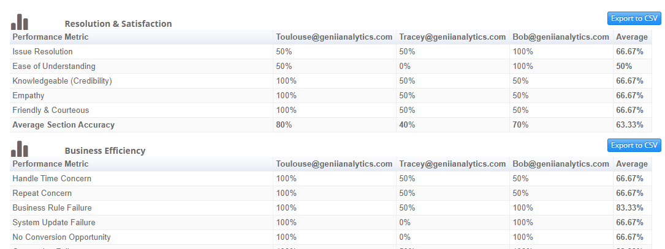

You will now be able to filter as follows with reference to the Gauge capture.

**Gauge details:**

(this will depend on your campaign)

1. Call Date
2. Captured Date
3. Agent
4. Team Leader
5. Service Lines
6. Call Reason
7. Sessions (Connection ID)

**Calibration details:**



1. Assessors